|  |  |  |  |
| --- | --- | --- | --- |
| **EKLP/JK/SK/Grade 1 Focus on the Pope and the 2013 Conclave**  The Pope as a Community Helper | | | |
| Teacher’s Note:  The experience of church for children this age is usually limited to their family’s own religious practice and their local parish. It’s difficult for them to conceive of a worldwide Church. However, you can introduce the pope as a community helper and important leader. | | | |
| CGE  A discerning believer formed in a Catholic faith community…I Believe! | | | |
| Curriculum Expectation  **Kindergarten**  **Religion: In God’s Image**  God sends many people to love and care for me  **Social Development**  Big Idea: Children are connected to others and contribute to their world  3.1 develop empathy for others, and acknowledge and respond to each other’s feelings  Emotional Development  Big Idea: Children have a strong sense of identity and well being  3.1 recognize people in their community and talk about what they do  **Language**  1.2 listen and respond to others for a variety of purposes  1.7 use specialized vocabulary for a  variety of purposes  4.5 experiment with a variety of simple  writing forms for different purposes  and in a variety of context  **The Arts**  D1.1 demonstrate an awareness of personal  interests and a sense of accomplishment in drama and dance | | Learning Goals  I share facts about the Pope and what he wears in complete sentences.  I complete my work and stay focused. | |
| **Grade 1**  New Elementary **Religious Education** Policy  Strand: Living in Communion  LC1.23 Compare the characteristics of a family with the characteristics of the Church  Praying  PR1.1 Identify times when Christians pray individually and in communal gatherings, when they pray daily and weekly.  **Social Studies**  Heritage and Citizenship: identify people with whom they have significant relationships, and the rules and responsibilities associated with people, places, and events in their lives and communities | |
| **Prayer/Scripture Reflection**  God of our Lenten Journey, We ask you to bless Pope Benedict XVI. Give him courage and strength as he leaves this special job.  Help him to feel better. Bless Your Church through the whole world  as we prepare for a new leader.  Amen. | | | |
| **Instructional Components** | | | |
| **Readiness**   * Participation at school and weekend parish mass * Can list a variety of occupations, including some within the Church and Catholic School Community * Familiarity with graphic organizer and the cooperative structure of Timed Think-Pair- Share | **Vocabulary/Terminology**  Pope  Leader of the Catholic Church  Miter  Cape  Sash  mass | | **Materials**  Photo of Pope Benedict from the School lobby  Copies of *Appendix 1*  One Prepared colouring page of Blessed John Paul II…red cape and red sash, white beanie and cassock/robe.  Note: The image could be also be transferred onto felt for constructing and deconstructing at a felt bored  Paper for Pope’s Special Hat (Appendix 2) |
| **Minds On**  Gather students on carpet.  Ask students to name different community helpers that they can remember and how they make the community a better place to live. Use puppets or other visuals to encourage conversation. | | | |
| **Activation:**  Say “There is a man, called the **pope**, who is the leader of all of the Church on earth – all of the parishes in every town – including our parish of ________________. The leader right now is Pope Benedict.  Here is a beautiful photograph of Pope Benedict. Does anyone know from what part of the school I got this picture from?  Continue: “I am sad because he is very sick, so he has decided to leave this job as Pope and let someone else be the **leader of the Catholic Church**. That way, Pope Benedict can get some rest, and the new leader will be able to do all of the things needed for this very big job.”  “Let’s stop and say a special prayer for Pope Benedict right now.”  “Like other special community helpers, Popes wear special clothing. I have a different Pope for you to look at. Throughout time, there have been many, many popes. This is Blessed Pope John Paul II (*Appendix 1*). “He was the leader of the Church before Pope Benedict. It was soon after he died that Benedict became Pope. These two men were very good friends.”  “Let’s study the picture of Pope John Paul II and look for picture clues to help us answer these questions: What does a Pope wear to do his job? Why do you think he wears these clothing items?”   * White Zucchetto (beanie) * Red Cape * Pectoral Cross * Red Sash * White Cassock/robe   “How are these items of clothing the same or different from what we wear? Turn and talk to your elbow partner.” Ask for answers and record comparison on an appropriate graphic organizer using pictures and words.  “When the Pope celebrates the mass, he wears a very special hat. It is called **a miter**. This is what it looks like.” (Add it to the coloured sample and show your sample.)” Everyone will make their own miter throughout the day. It will be fun to dress up like a pope!”  On the page, students will colour the sash and cape red and add a miter on Pope John Paul II’s head.  Refer to *Appendix 2: Instructions for making a Special Pope Hat.*  In small groups, modeled by the teacher, students will fold and decorate a pope’s miter. | | | |
| **Consolidation**  Students will use complete sentences to talk to each other, and then the teacher, about facts they recall about Popes using visual and printed text/images found around the room to assist them.  Add the miter and other religious clothing items (i.e. ponchos in green, purple, white, a pectoral cross,etc.) to the Dress Up Centre.  Extensions:   1. Pray the prayer for Pope Benedict often leading to the end of the Conclave. 2. In EKLP, listen for any play-based inquiry questions that can extend the learning. 3. Invite your parish pastor to “show and tell” his vestments and talk about his vocation and service to others. This will foster a personal relationship between him and your students and give him a purpose for visiting the school. 4. Borrow from the CRC, the newly purchased priest puppet or the Mass Kit. Include these at the Puppet Centre/Drama Centre/Dress Up centre along with the Pope’s miter that were made. | | | |
| **Co-operative Structure**  **Timed Pair-Share**  This variation of Think Pair Share adds a time component. Students share ideas with each other for the prescribed period as designated by the teacher. This structure is ideal when answering open-ended questions.  1.  The teacher poses a question and provides think time.  2.  Students pair up and identify as either A or B.  3.  Partner A shares ideas  with Partner B for 30 seconds,1 minute, etc.  4.  Roles switch. | | | |

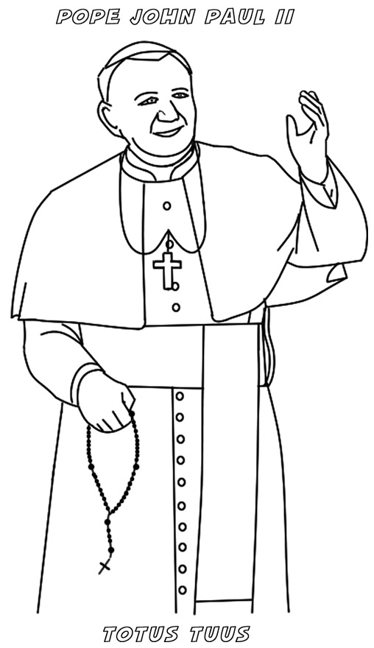

My name is ____________________________

Colour the cape and sash red.

Add the miter to the pope’s head.

Print miter.

___________

Instructions for Making a Special Pope Hat

From: <http://www.catholicmissionaryfamily.com/2011/02/paper-bishop-miter-or-pope-hat.html>

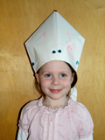 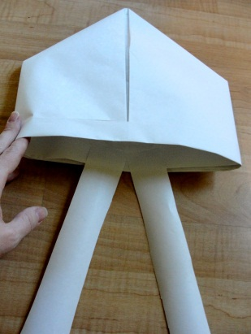

To start you need:

* Roll of paper
* Tape
* Scissors

Step 1: Cut a piece of paper that is about 20 x 24 inches.

Step 2: Fold it in half hamburger style from the top to the bottom, so the crease is at the top of the paper.

Step 3: Fold the top right and left corners in to meet in the middle and for a triangle. There will be a little strip left on the bottom, this is good.

Step 4: Fold the top piece of the bottom strip up.

Step 5: Flip the hat over and do the same with the other strip.

Step 6: Fold the bottom right and left points in to form the hat. You can adjust the hat size by folding them in more or less.

Step 7: Add some strips to the back inside of the hat.